Operational Report
For
AES Energy Storage
Barbados
Page I Completed
Version 2.1

September 2010
Table of Contents

Table of Contents ii
Revision History ii
1. Summary 1
2. Maintenance and Change Requests 4
3. Events 5
4. Conclusions 6

Revision History

Name | Date | Reason For Changes | Version
Isaiah Jefferson | June 9, 2010 | Initial Draft | 1.0
Curretly ,Table of content is static.
“Revision History” removed

Summary
Pending
  - Financials $???
Daily
- Average price year to date
- Average price budgeted year to date
- Day ahead regulation price
Monthly
- Monthly average regulation price
- Monthly budgeted average regulation price
- Monthly Income Statement vs. Basecase

  - The Availability Factor (AF) target for Barbados is 95%. The AF in September was 84% down from 95% in August; The AF for Q3 2010 is 85% and YTD AF is 88%.
Pending

- OF (Outage Factor)
- FOH (Forced Outage Hours)
- Service Factor
- Number of container trips

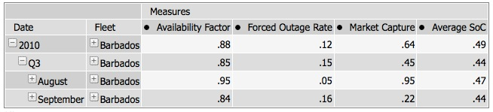
Completed

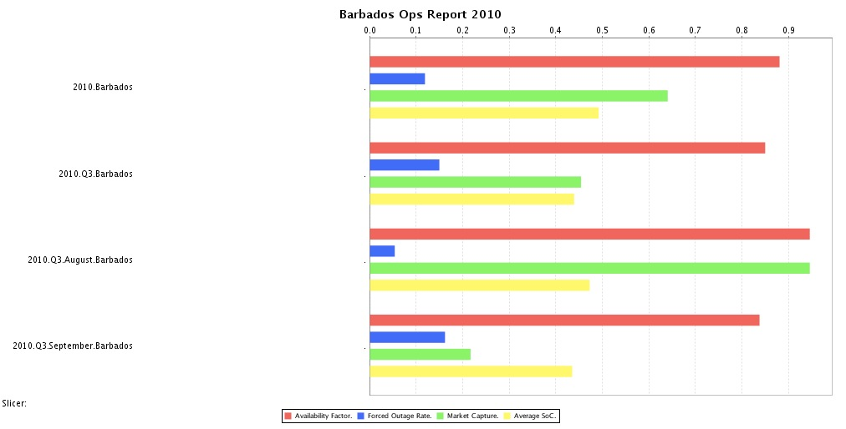
Completed

  - Barbados Daily Availability Factor was below 80% ten days during the month of September
- Losses
  - Net Energy (Monthly kwh consumed)
Pending
  - Losses from Regulation
  - Aux Power
- Watt Hour Thruput
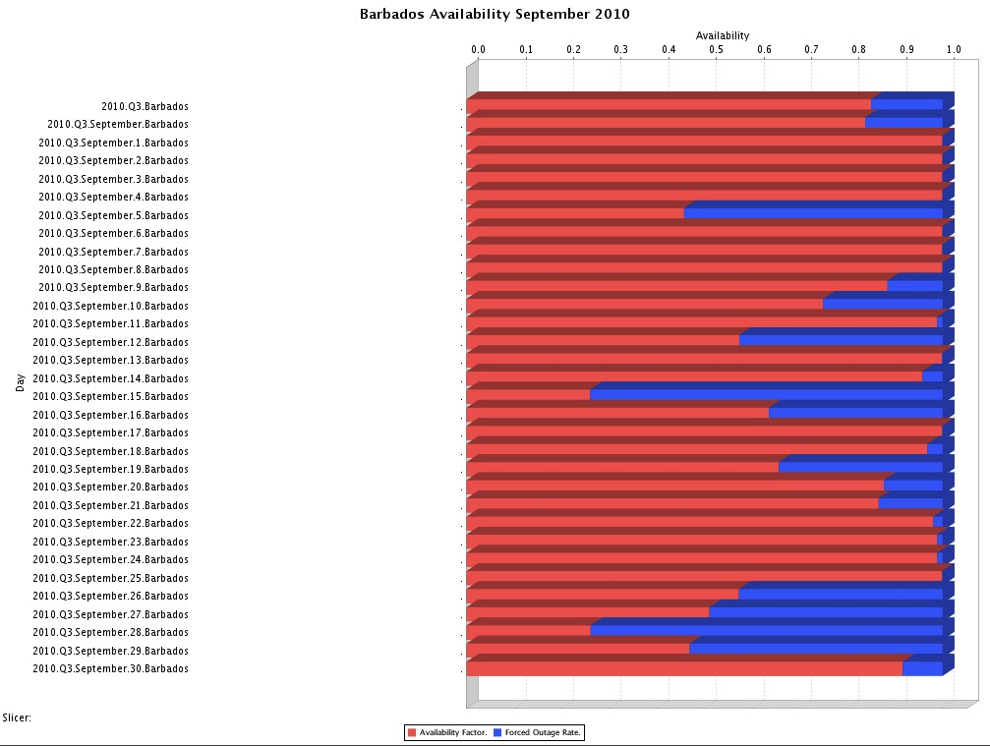
- Performance Index
- Average and Max C-rate
Completed
  - Environmental

Monthly
Pending
- Number of cooling medium leaks

Maintenance and Change Requests
Completed
  - There were 2 Change Requests schedule for completion in September 2010
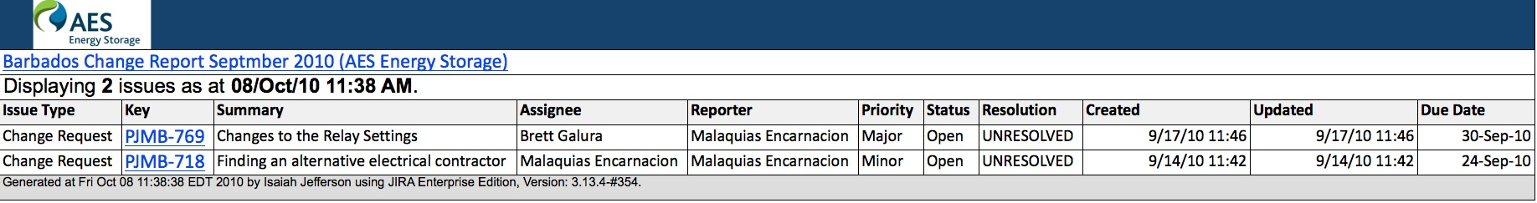
Maintenance KPIs:
- Number of work orders dispatched
- Number of warranty calls by Vendor
- Ratio of completed PMs vs. Work Orders

Need to add into CMMS:
- Electrical equipment PMs and notification addresses
- Chiller PMs and notification addresses
Jira will serve as a full maintenance log.

Safety
Additional tab will be inserted into safety walk form to summarize safety walks into the following table:
Pending
Date | Project | Who | Type of safety ofservation | Action required

Safety KPIs:

AES People

- Number of LTIs
- Number of recordable
- Recordable rate
- Number of near misses
- Number of safety walks
- Date since last LTI
Contractors

- Recordable
- Man hours worked
- Recordable rate

Completed
(Barbados Alerts generated from Jira is included in this section)

Events
  - There were 203 Events registered in September 2010. Top 5 days account for 122 Events

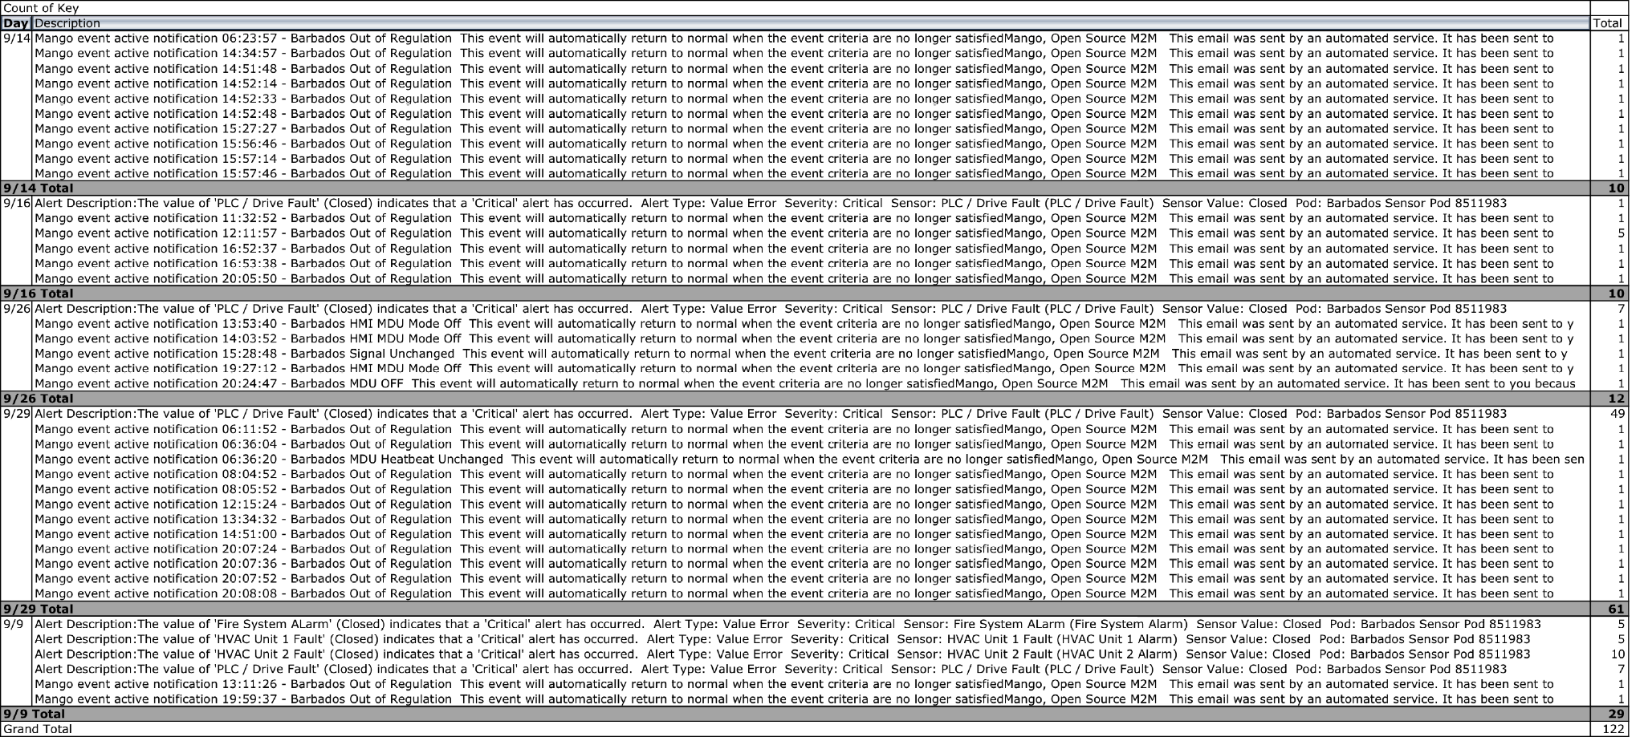

Conclusions
Removed for now

